Web PULS Login instructions (New URL)

Background:
Current Web PULS application login through VCAM (https://pulsweb.volvocars.biz/wl01) will soon be decommissioned and will be replaced by a new URL - https://pulsweb-partslogistics.volvocars.biz/wl01

What will change?
From the Old login screen (via VCAM):
1st login with the CDSID
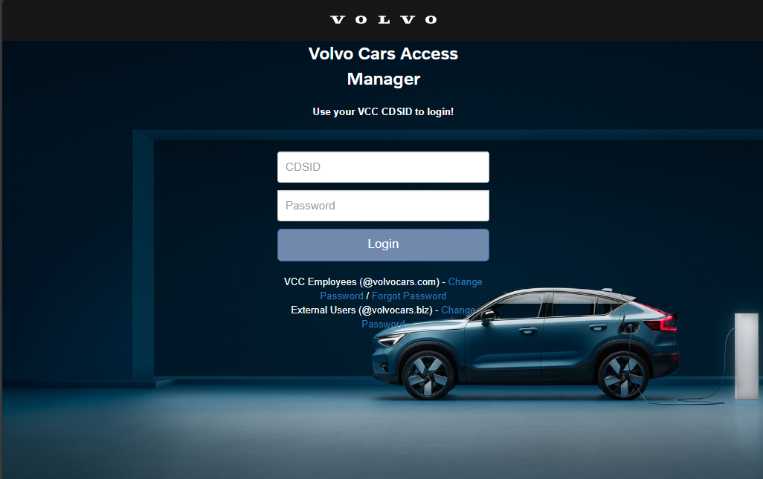

2nd with the ACF2ID (usually starts with P, example PHL1C..)

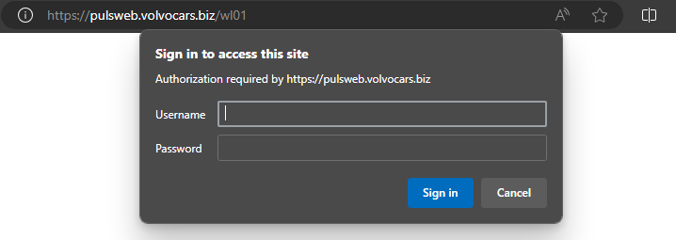

To the New login screen (via Azure AD):
1st login with the CDSID

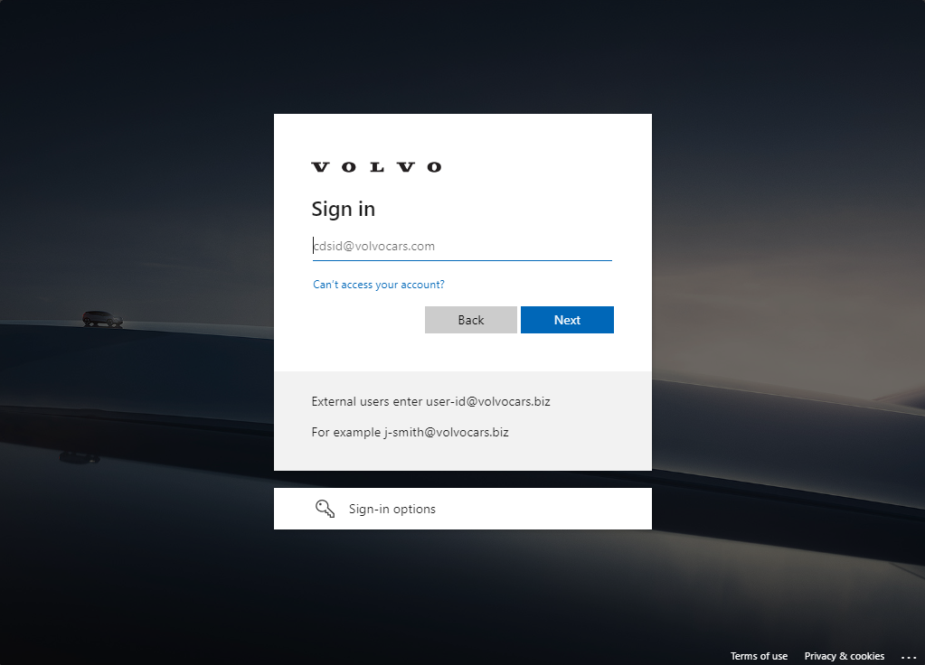
2nd with the ACF2ID (usually starts with P, example PHL1C..)

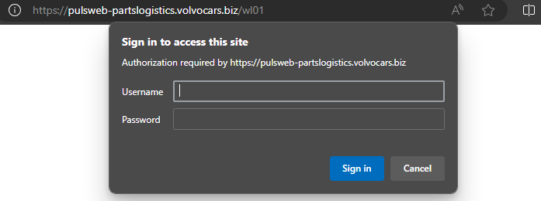
What will NOT change?
- No application changes. Meaning its same Web PULS functionality in both logins.
- Two step login (CDSID + ACF2/PCxxxxx ID)

How to login using the new URL?
Prerequisite:
Verify if your current password for CDSID satisfies the below criteria. If not, you need to change your password first before proceeding further.

- 10 characters or more
- At least one upper case, one lower case, one special character and one number
- Not in the list of last 5 passwords
- No first name or last name or DCxx, Volvo or vcc in the password text

Step 1:
Enter your CDSID in the below format.
CDSID@volvocars.com (for Internal users)
CDSID@volvocars.biz (for External users) Ex: (1-DC99@volvocars.biz)

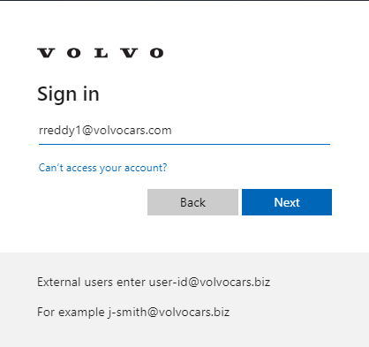

Step 2:
Enter password for your account.
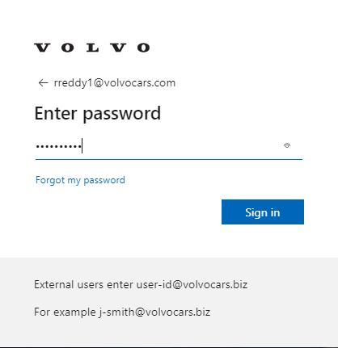

Step 3:
- Enter your ACF2 or PC id and password.
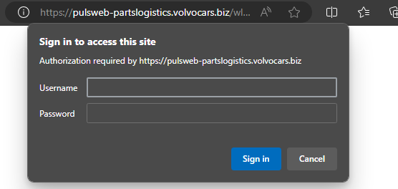
Note:
- If your account has MFA enabled, then you might get another prompt after Step 2 above.
- If you are accessing the URL from Volvo Cars computer or if you are already logged into other Volvo Cars web application using your CDSID@volvocars.com account in the same browser session, then you are directly taken to Step 3.
- If you have multiple accounts and you don’t see your Volvo cars account in the list, click on Use another account and then follow Step 1 to 3.
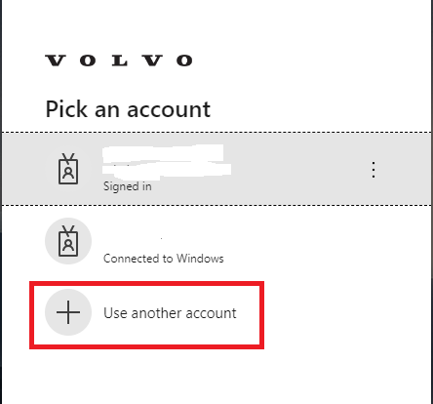
Temporary MFA solution until there is a Token based one.

Manually add SMS MFA in Azure
Target Audience: End Users without smartphone.
Scenario: Manually registering for MFA before it becomes mandatory.
Note: The recommended method Is the Microsoft Authenticator App, but we still allow SMS to Phone as a fallback.
To add a new authentication method, go to the new Combined Portal, that registers both MFA and SSPR:
https://aka.ms/mysecurityinfo
If you are prompted for MFA here, you already have an MFA method configured.
If you can complete that MFA prompt, you are all set.
If you cannot complete the MFA prompt the wrong data may be registered, and you need to contact support.
If you do not have any MFA methods registered, you will come to an empty Security info page:
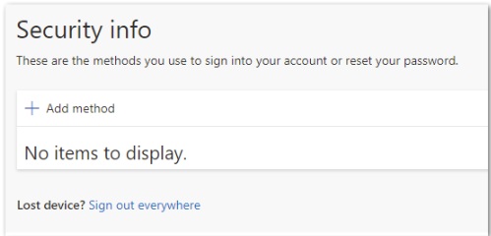
Click Choose a method,
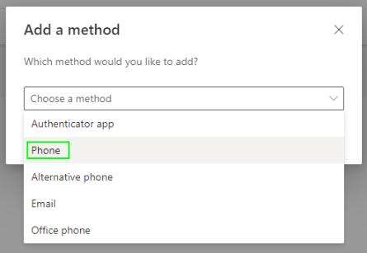
Select your Country and Enter your phone number. Choose text me the code. Do not use the Call me option (since anyone with access to the phone can answer a phone call). Click Next.
Note that this phone number is considered sensitive and will not be shown to other users. It can be a different one that your company phone number.
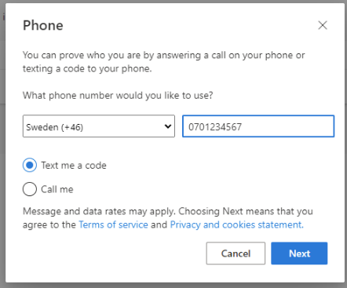
You should receive a text from Microsoft with a verification code:
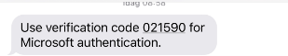
Write the verification code into the required field.
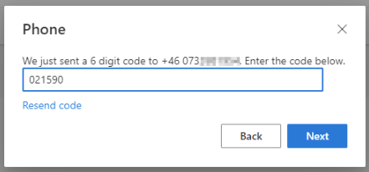
The number should be verified successfully. Click Done:
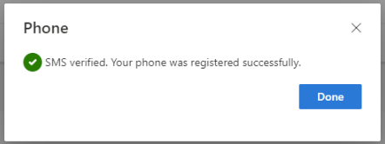
Your new method should be added to the list of methods:
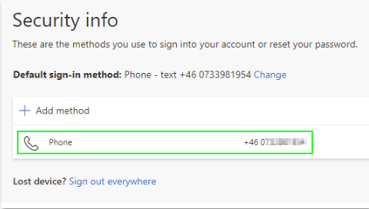
You can always go back to
https://aka.ms/mysecurityinfo
to Add, Change or Delete your authentication methods.

